Problem 1 (30 pts): Two reactants A and B react in the cell cytoplasm to produce two products X and Y. Y is utilized in a subsequent reaction as fast as it is produced, so that its concentration remains virtually zero. That makes the reaction irreversible. The irreversible chemical reaction equation is
$A+B \underset{→}{k} X+Y$
Let a, b, x, and y denote the respective concentrations of each substance. Assume that the initial concentrations are: a₀ = 10.5 $μg/ml$, b₀ = 6.5 $μg/ml$, x₀ = 0, y₀ = 0. The rate of reaction constant is k = 2.0/s.
You have to take into consideration conservation of mass.

- Assess each of the statements below, say whether the statement is true or false and substantiate with logical explanation.
  - The model of the reaction kinetics is $\frac{dx}{dt}=2\left(10.5-x\right)\left(6.5-x\right):$ (True/False)
True this model equation accurately describes kinetics defining a=10.5-x, and b=6.5-x, with a rate constant of k=2.0/s. Using $A+B \underset{→}{k} X+Y$ and the concept of rate reactions. We can assume that the product should be proportional to the concentration of the reactants. We use x to represent the x and y of concentrations. This is due to the initial concentration of Y=0 and Y is used in the following reaction as fast as it is produced. Since it’s being used so quickly with it is best to denote the equation with just x.
  - The model of the reaction kinetics is $\frac{dx}{dt}=2\left(10.5-x\right)\left(6.5-y\right):$ (True/False)
False this model equation inaccurately describes a separate variable y, which means we can’t assume conservation of mass or mass action laws. The equation above states that the concentration of B is constant with the concentration of Y. However, the concentration of Y is dependent on the depletion and use of B. The concentration of Y is dependent on the concentration of X, due to the conservation of mass and mass action laws. So in this equation the product would be 2x and not X+Y, to model this accurately, we need A-X and B-X
  - Reactant A gets depleted first. (True/False)
Since A_0 > B_0 (10.5 >6.5) Reactant B is the limiting reactant will be fully used first. We need everything to proportional so that it follows mass action laws, meaning that in this reaction everything would be a 1:1 ratio.
- Next, create a Simulink simulation of the correct model.
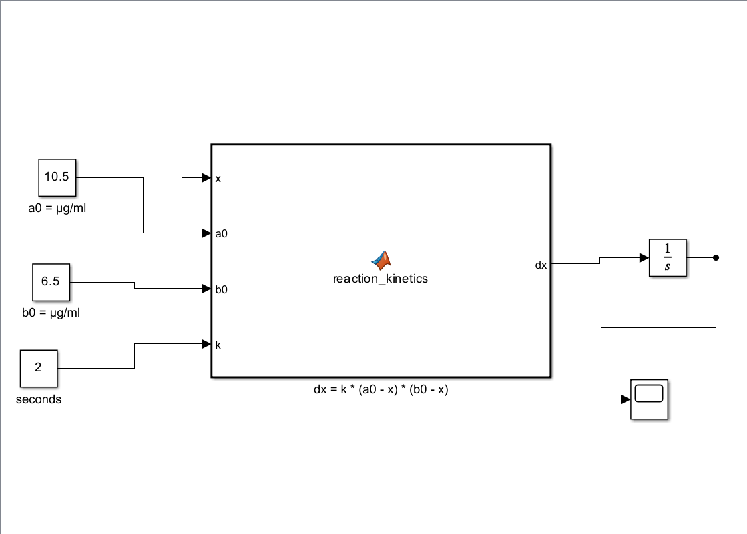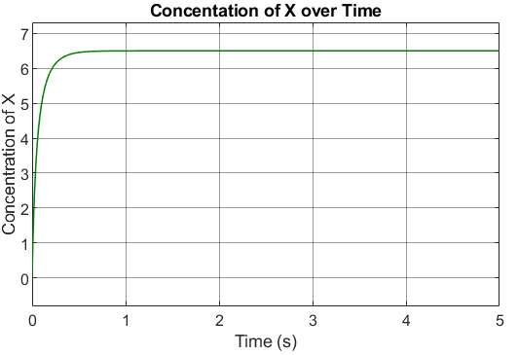
- Finally solve the differential equation of the correct model using Matlab symbolic language
- %Define symbolic Variables
- syms x(t)

- %Define Differential Equation
- dx=diff(x,t)
- dx(t) =
- 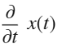
- ode=dx==2*(10.5-x)*(6.5-x);
- %Set initial conditions
- Initial_Condition= x(0)==0;
- %Soliving the Differential equation
- sol= dsolve(ode, Initial_Condition);
- %simplify the solution
- sol=simplify(sol);
- %Soltuion Display
- disp('The concentration of X as a function of time is:');
- The concentration of X as a function of time is:

- disp(sol);
- 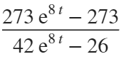
- % Simplify and plot the solution
- simplified_solution = simplify(solution);
- figure('color', 'w');
- fplot(simplified_solution, [0, 5]);
- title('Concentration of Product X over Time');
- xlabel('Time (seconds)');
- ylabel('Concentration of X (\mug/ml)');
- grid on;

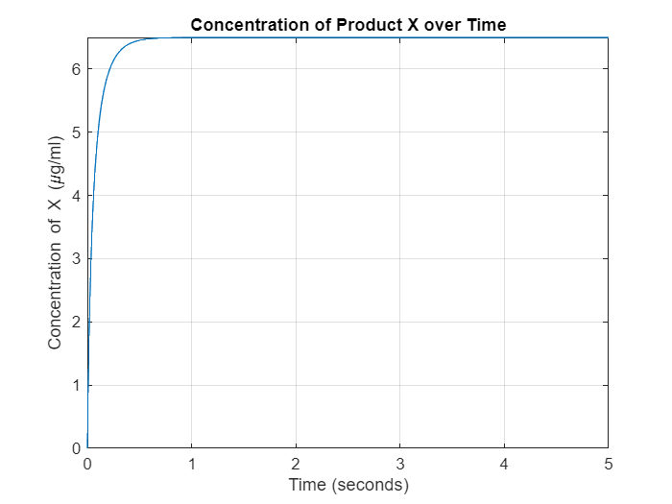
Problem 2 (40 pts)
(see diagrams below)
Consider the following irreversible intracellular reaction in which one mole of X reacts with one mole of Y to create one mole of Z with forward rate constant of k₁. Denote the concentrations of X, Y and Z as x, y and z (respectively). Both X and Y diffuse into the cell from the extra-cellular fluid (ECF) with diffusion coefficients of k_{x} = 2 $\frac{μg}{sec}$and k_{y} = 3 $\frac{μg}{sec}$ (respectively). Extracellular X and Y are carried by albumin and there is a large reservoir of each in the carrier state. We are only interested in the free X and Y. Because there is a large reservoir, we can assume that the concentrations of free X and Y in the extracellular fluid are constant and equal x_{0e} = 10$μg/mg$ and y_{0e} = 6 $μg/mg$. Assume that the initial conditions for all intra-cellular fluid (ICF) reactants and product are zero: x_{0 i}= y_{0i} = z_{0i} = 0.
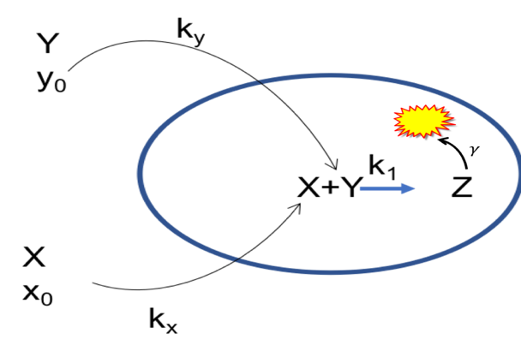Also we know that the product of this reaction, Z, is consumed by a subsequent reaction in the cell proportionate to its concentration with a proportionality constant of $γ=2/sec$
Furthermore, there is a negative feedback mechanism where z, the concentration of Z, inhibits the forward progress of the reaction, X+Y Z, in the following way: $k_{1}=α-βz$ and k₁ is always $≥0$ (see graph)
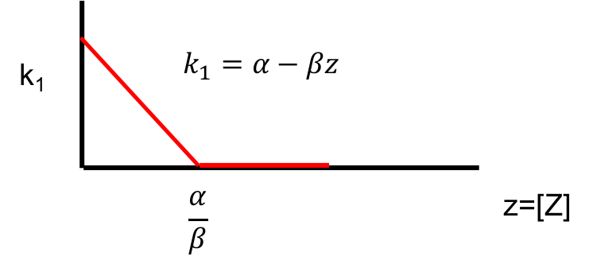
Let $α=10 \& β=2. Clearly, as z→\frac{α}{β} , k_{1}→0 and the reaction will stop if k_{1}=0$
Write the dynamical system that describes this situation (differential equations)
- Create the Simulink model for a numerical solution. Run the model for 5 seconds. Present your output (don’t forget labels, title, etc.). The presence of Z inhibits its own production, but Z is also consumed thus reducing its presence
- Identify equilibrium point(s). What are they (numerical values)?
The equilibrium points are X=5.306, Y= 2.8731, Z=4.691
- What happens to k₁? Does it go to zero? If not, what is its final value
K1 does not go to 0,
- Does the operation stop or just reach a steady state?
Yes the operation does reach a steady state
clc; clear; close all;

% Parameters
kx = 2; ky = 3; gamma = 2;
alpha = 10; beta = 2;
x0_e = 10; y0_e = 6;

% Initial conditions
x0 = 0; y0 = 0; z0 = 0;
t_end = 5; dt = 0.01;
t = 0:dt:t_end;

% Initialize variables
x = zeros(size(t)); y = zeros(size(t)); z = zeros(size(t));
x(1) = x0; y(1) = y0; z(1) = z0;

% Euler Method Simulation
for i = 1:length(t)-1
k1 = max(0, alpha - beta * z(i)); % Enforce k1 >= 0
dx = kx * (x0_e - x(i)) - k1 * x(i) * y(i);
dy = ky * (y0_e - y(i)) - k1 * x(i) * y(i);
dz = k1 * x(i) * y(i) - gamma * z(i);

% Update values
x(i+1) = x(i) + dt * dx;
y(i+1) = y(i) + dt * dy;
z(i+1) = z(i) + dt * dz;
end

% Plot results
figure;
plot(t, x, 'r', 'LineWidth', 2); hold on;
plot(t, y, 'b', 'LineWidth', 2);
plot(t, z, 'g', 'LineWidth', 2);
xlabel('Time (seconds)');
ylabel('Concentration');
legend('X (Reactant)', 'Y (Reactant)', 'Z (Product)');
title('Time Evolution of Concentrations');
grid on;
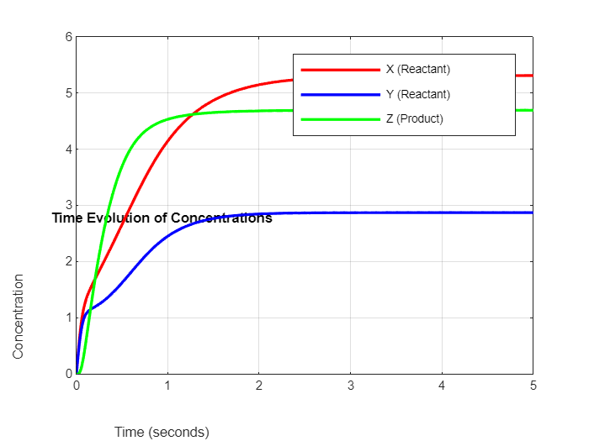

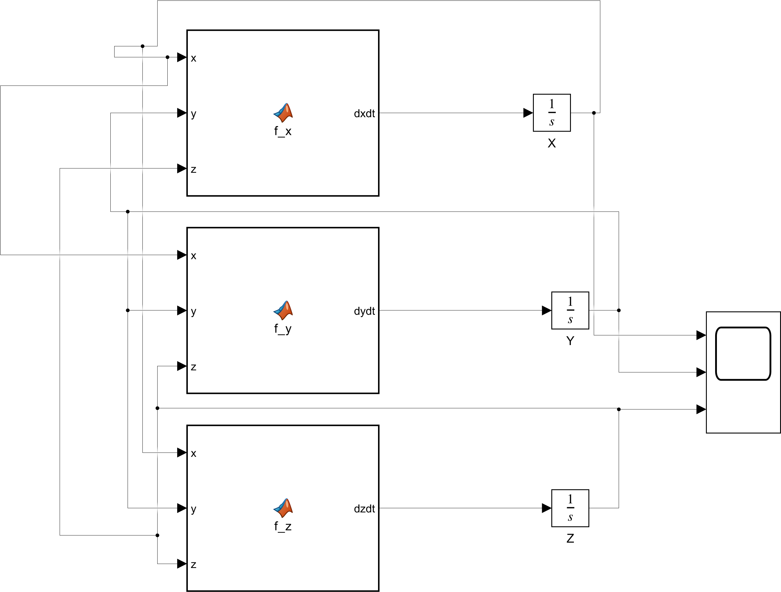
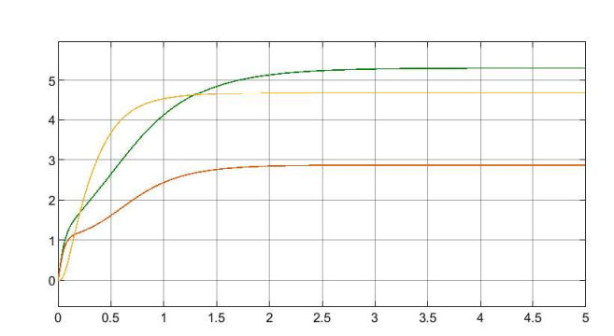

Problem 3 (30 pts)

A nerve cell has the following ionic concentrations inside and outside the cell:

Inside | Outside
Na⁺ 14 mMol | 140 mMol
K⁺ 140 mMol | 4 mMol

The measured membrane potential = -79.3 mV.
Note that R = 8.3 J/K,
temperature = 37⁰C,
F = 96500 C/mole
Z=1 for both ions
$2.303\frac{RT}{ZF}=61.5$ using log base ten
Assume that Na+ and K+ are the only permeable ions.
The ratio of gNa:gtotal = 0.1,
the ratio of gK:gtotal = 0.9

ion conductance for each ion is a constant and does not change with changing ion concentrations.
- Calculate what happens to the membrane potential if extracellular K⁺ is increased by 25 mM. Show your work.
(Note this problem can be solved with pencil, paper, & calculator, with Matlab command window – be sure to use the correct log function - , or on Excel equally easily)
- clc; clear; close all;

- % Given parameters
- R = 8.3; % Gas constant (J/K)
- T = 310; % Temperature in Kelvin (37°C)
- F = 96500; % Faraday's constant (C/mole)
- Vm_original = -79.3; % Original membrane potential in mV

- % Nernst constant (2.303 * RT / F using log base 10)
- nernst_constant = 61.5; % mV

- % Ionic concentrations before the increase in extracellular K+
- Na_in = 14; % mM
- Na_out = 140; % mM
- K_in = 140; % mM
- K_out_original = 4; % mM

- % New extracellular K+ concentration after increase
- K_out_new = K_out_original + 25; % 29 mM

- % Permeability ratios
- P_Na = 0.1; % Relative permeability of Na+
- P_K = 0.9; % Relative permeability of K+

- % Original membrane potential calculation
- Vm_initial = nernst_constant * log10((P_Na * Na_out + P_K * K_out_original) / (P_Na * Na_in + P_K * K_in));

- % New membrane potential after increasing extracellular K+
- Vm_new = nernst_constant * log10((P_Na * Na_out + P_K * K_out_new) / (P_Na * Na_in + P_K * K_in));

- % Display results
- fprintf('Original Membrane Potential: %.2f mV\n', Vm_initial);
- Original Membrane Potential: -52.87 mV
- fprintf('New Membrane Potential after increasing K+ by 25 mM: %.2f mV\n', Vm_new);
- New Membrane Potential after increasing K+ by 25 mM: -30.87 mV
- fprintf('Change in Membrane Potential: %.2f mV\n', Vm_new - Vm_initial);
- Change in Membrane Potential: 21.99 mV

- Research the concept of membrane voltage threshold and action potentials.
  - Write a short essay explaining what this entails.
A Membrane voltage threshold is the voltage level on a cell membrane that when reached will cause an action potential reaction. Action potential is rapid, almost immediate electrical signal that travels along the cell membrane. This is the most common method of communication between neurons in the nervous system. Around -55mV is the level a cell must normally reach to trigger the action potential reaction. This threshold is stabilized/maintained by the sodium and potassium ions located in and across the cell membrane.
The action potential reaction has three main phases: Depolarization, Repolarization, and Hyperpolarization. During depolarization the sodium channels open, which allows for sodium to enter the cell. This rapidly increases the membrane potential to around +40mV. In repolarization phase, the sodium channels close while the potassium channels open. This restores the negative resting potential. Occasionally the membrane will become increasingly negative before they stabilize again, which is called hyperpolarization.
The membrane voltage threshold and action potential reaction are vitally important to the body for neural communications. The action potential enables the transmission of information from different parts of the body. This allows for the correct stimuli response
  - The extracellular potassium ion level can be suddenly increased by 25 mMol/L, say by intravenous injection of KCl. Why do you think that this will be a lethal injection?
There would be a disruption in the membrane potential. Our hearts rely on a balance of potassium ions to conduct their electrical signals. A large increase in potassium will depolarize the concentration, which will result in shock, i.e. heart attack. This will be known through the irregular heartbeats coming from the drastic difference in concentration. This can also lead to cardiac arrest caused by the massive depolarization for a long or sustained period.

